**DESIGN AND IMPLEMENTATION OF COMPUTERIZED AIRLINE RESERVATION SYSTEM**

**BY**

**BILKISU MUHAMMAD AHMAD**

**NAS/STE/19/1008**

**A PROJECT SUBMITTED TO THE DEPARTMENT OF SOFTWARE ENGINEERING AND CYBER SECURITY, COLLEGE OF COMPUTING AND INFORMATION SCIENCE,**

**AL-QALAM UNIVERSITY, KATSINA**

**IN PARTIAL FULFILLMENT OF THE REQUIREMENTS FOR THE AWARD OF BACHELOR OF SCIENCE DEGREE IN SOFTWARE ENGINEERING**

**NOVEMBER, 2023**

**DECLARATION**

I hereby declare that this project work titled “Design and Implementation of Computerized Airline Reservation System” is my original work, undertaken under the supervision of **Mal Yusuf Abubakar Sadiq**, and the work has not been submitted to any higher institution for any academic award. All sources used have been duly acknowledged.

___________________________ ________________________

Bilkisu Muhammad Ahmad Date NAS/STE/19/1008

**CERTIFICATION**

This is to certify that the project work titled “Design and Implementation of Computerized Airline Reservation System” by **Bilkisu Muhammad Ahmad NAS/STE/19/1008**, was carried out under my supervision.

_________________________ _____________________

Mal Yusuf Abubakar Sadiq **Date**

**Project Supervisor**

**APPROVAL PAGE**

This project work titled “Design and Implementation of Computerized Airline Reservation System” has been read and approved as meeting the partial requirement for the award of Bachelor of Science degree in Software Engineering of Al-Qalam University, Katsina.

**___________________________ ________________________**

Mal Mardiyya Lawal Bagiwa Date

Project Examiner

**___________________________ ________________________**

Mal Yusuf Abubakar Sadiq Date

Project Supervisor

**___________________________ ________________________**

Mal Yusuf Abubakar Sadiq Date

Project Coordinator

___________________________ ________________________

Dr. Armaya’u Umar Zango Date

Head of Department

**DEDICATION**

This project is dedicated to my respectful parents whose guidance, support, encouragement and prayer help me towards my educational career. May Allah (SWA) The One, The Last, The Beginning, The End, The Merciful and The Sufficient protect the whole Muslim sisters & brothers around the globe, ease their suffering and provide them with the highest place in his paradise, Amin!

**ACKNOWLEDGEMENT**

I thank Allah SWT for the gift of life, keeping our soul superfluous and in a splendid condition up to this level of my academic pursue.

I extend my humble and sincere appreciation to my supervisor, Mal Yusuf Abubakar Sadiq for his untiring efforts, advice and recommendations rendered to me in the course of executing this project which in turn, made its successful compilation possible with a nominal or no breaches to academic regulations prescribed by the Department of Software Engineering and Cyber Security, Al-Qalam University Katsina.

I must non-stop my sincere appreciation and gratitude to my able HOD in person of Dr. Armaya’u Umar Zango, and the entire lecturers of the department amongst Malam Suleiman Hayat Tuge, Dr. Usman Hamza and others, May Allah SWT reward you abundantly Amin!.

Finally, my infinite gratitude goes to my family and friends for their support, prayers and encouragements, May Allah Bless you all!

**TABLES OF CONTENT**

Title Page i

Declaration ii

Certification iii

Approval page iv

Dedication v

Acknowledgement vi

Tables of Content vii

List of Tables x

List of Figures x

Abstract xi

**CHAPTER ONE:** Introduction

1.0 Introduction 1

1.1 Background of the Study 1

1.2 Statement of the Problems 2

1.3 Aim and Objectives of the Study 3

1.4 Scope of the Study 3

1.5 Significance of the Study 3

1.6 Summary 4

**CHAPTER TWO:** Literature Review

2.0 Introduction 5

2.1 History of Airline Reservation System 5

2.2 Conceptual Review 6

2.2.1 Online Ticket Booking 7

2.2.2 E-commerce and Its Development 7

2.3 Reservation Information Systems 7

2.4 Components of Reservation Information Systems**.** 8

2.4.1 Hardware 9

2.4.2 Software 9

2.4.3 Data 9

2.4.4 People 9

2.4.5 Procedures 9

2.4.6 Database 9

2.5 Types of Reservations in Reservation System 10

2.6 Types of Information System 10

2.6.1 Transaction Processing System (TPS) 11

2.6.2 Management Information System (MIS) 11

2.6.3 Decision-support systems (DSS) 11

2.6.4 Executive Support System (ESS) 11

2.7 Advantages of Reservation Information Systems 12

2.8 Chapter Summary 12

**CHAPTER THREE:** System Analysis and Design

3.0 Introduction 13

3.1 Software Development Model 13

3.1.1 Justification for using the Waterfall Model 13

3.2 Requirement Engineering 14

3.2.1 Feasibility Report 14

3.2.2 Requirement Elicitation Analysis 15

3.2.3 Requirements Specification 15

3.2.4 Requirement Verification & Validation 18

3.3 System Design 18

3.3 Use case 19

3.3.2 Activity Diagram 19

3.3.3 Entity Relationship Diagram 21

3.4 Chapter Summary 22

**CHAPTER FOUR:** System Implementation

4.0 Introduction 23

4.1 System ImplementationTools Used 23

4.2 System Testing 23

4.3 System Requirement 24

4.4 Chapter Summary 25

**CHAPTER FIVE:** Summary, Conclusion, and Recommendation

5.0 Introduction 26

5.1 Summary 26

5.2 Conclusion 27

5.3 Recommendation 27

**REFERENCES** 28

**Appendix A:** Screen Shoot of Each Interface of the System 31

**Appendix B:** Github Repository of the System 36

**LIST OF TABLES**

|  |  |  |  |
| --- | --- | --- | --- |
| **S/N** | **Table Caption** | **Table Number** | **Page Number** |
| **1** | Feasibility Report | Table 3.2.1 | 14 |
| **2** | Functional requirement | Table 3.2.3 | 15 |
| **3** | System test cases | Table 4.2 | 23 |

**LIST OF FIGURES**

|  |  |  |  |
| --- | --- | --- | --- |
| **S/N** | **Figure Caption** | **Figure Number** | **Page Number** |
| 1 | Showing a global distribution system | Figure 2.1 | 8 |
| 2 | Five Stages of Transaction Processing System | Figure 2.2 | 11 |
| 3 | Showing a Waterfall Development Life Cycle | Figure 3.1 | 13 |
| 4 | Use case Diagram | Figure 3.3.1 | 19 |
| 5 | Showing Activity Diagram for a Customer | Figure 3.3.2.1 | 20 |
| 6 | Showing Activity Diagram for Admin | Figure 3.3.2.2 | 21 |
| 7 | Showing Entity relationship Diagram | Figure 3.3.3 | 22 |

**ABSTRACT**

Airline Reservation Systems (ARS) used to be standalone systems. Each airline had its own system, disconnected from other airlines or ticket agents, and usable only by a designated number of airline employees. Travel agents in the 1970s pushed for access to the airlines' systems. Today, air travel information is linked, stored, and retrieved by a network of Computer Reservations Systems (CRS), accessible by multiple airlines and travel agents. This report is a summary of the study that was undertaken to design and implement computerize airline reservation system. The airline reservation system designed in this project was developed using PHP as the programming languages and MySQL as the database Management system.

The researcher reviewed the literature of reservation systems in chapter two and explored the advantages and limitations of reservation system in real life situations. The researcher used brainstorming and prototyping methods during the data collection phase, these data collection methods helped the researcher to better understand the system in use.

In conclusion, The Airline Reservation System has led to ease of airline ticketing, flight scheduling and also provided a means for customers to access and book flights from their homes. It has also increased the speed with which information about customers are retrieved and handled and flight scheduling is tasked.

**CHAPTER ONE**

**INTRODUCTION**

1. **Introduction**

In this chapter, we embark on a journey to explore the Design and Implementation of a computerized Airline Reservation system. The purpose of this chapter is to provide an overview of the subsequent sections, outlining the context, objectives, scope, and significance of the study. As we delve into dynamic landscape of the Airline industry and the evolving technology ecosystem, the chapter lays the foundation for the comprehensive investigation that follows.

**1.1 Background of the Study**

In recent times, the world has experienced a huge boom in terms of technology, with innovation in every area making the human life more comfortable and our tasks easier, efficient and completed within a shorter period of time. This upsurge in terms of technology has also made immense impact in the Airline transport industry. The Airline industry has evolved into one of the most sophisticated and fascinating industries today. The invention of airplanes totally has revolutionised transport and more people use planes as it is the fastest means of transport. The movement of people to places previously considered unreachable by land or too distant, has not only connected people and cultures but has strengthened the economy of visited countries.

As we all know, to make a reservation for a seat on a plane, you need tickets. When air transport initially began, manual reservations were the only means of securing a place on the flight. The officials made use of paper tickets, pen-and-paper writing of customer and flight information. As more people continued to patronize the industry and the advent of the internet/globalization, online ticket booking systems were introduced and established. With the help of the internet, the way transactions take place has changed drastically which has been able to remove the barrier of time and location [3].

Tickets are the documents that confirm purchase and guarantee entry and a seat on an airplane for a chosen journey. All major airlines have adopted the use of ‘e-tickets’. An e-ticket contains the passenger information like name, date of travel, rules on changes and refunds, payment forms and validity of tickets. Online reservations have ensured that airlines create a fully mobile and social environment with the intelligent use of vast quantities of data to deliver real service and operational improvements [2].

Reservation is a written record of an arrangement in which something such as a seat on an airplane is kept for a customer [4]. Evolving from manual records and logs in the early 1930s, Airlines Reservations System (ARS) is the improved, computerized feature of airline reservations. ARS helps in systematic, efficient and effective organization of bookings, prices, schedules and customer data. Online airline reservation or e-ticket booking is a kind of user assistance where customers can book tickets for flight online. This is an easy method which saves a lot of time. Airline Reservation Systems were first introduced as relatively simple standalone systems to control flight schedules, maintain flight inventory, seat arrangements and aircraft loading [3].

Pooja,(2015) stated that modern ARS comprises of a detailed and complete suite of packages that assists a variety of airline management tasks and customer needs from the reservation process to the entire flight completion. ARS has today evolved into Computer Reservations System (CRS). Computer reservation systems are classified as Passenger Service Systems (PSS) which handles a series of critical functions for the airline. When CRS is integrated with Global Distribution System (GDS), it can be used by multiple distribution channels such as travel agencies, who can then use it for hotel rentals, flight booking, car hires as well as activities and tours via a single system.

In this project, the system behind online ticket booking and reservation was explained and a working application was provided to give a sample online reservation for a passenger. To this end, sources like e-books, online articles, journals and websites had been consulted to gather relevant information about the project.

**1.2 Problem statement**

In the past years, ticket booking and reservation were performed manually and a lot of documentation were required. There were always lengthy queues at the organizations and there was an enormous chance of the officials cheating. Situations had also occurred where customers were unable to create cancellations in the current internet scheme after booking in a case where they are unable to move again. Another frequently occurring problem is the issue of people breaching security by accessing passengers’ login details which resulted in safety concerns. Therefore this project solved the identified problems with the stated objectives.

**1.3 Aim and Objectives of the Study**

The aim of this project is to automate the process of airline ticket reservation, booking and airline management which would minimize errors that resulted from manual system operations. The specific objectives are to:

* To understand the requirement of Airline reservation system.
* To propose a design for the Airline reservation system.
* To implement an Airline reservation system with the propose design.

**1.4 Scope of the Study**

This project designs and implements the reservation system for airlines. Supported by a well-designed database, all accessible air aircraft data was incorporated together and can be readily obtained through a single point. A pleasant customer interface was supplied so that different combinations of search requirements can be obtained from the customer and the respective data base search statements are generated. The air ticket reservation system provides both customer and administrative interfaces with the latter used for administration purposes. The advanced scheme enables internet reservation; maintains client documents, provides an internet menu on flight plans, flight locations and their rates. It does not include catering for personnel wage calculations and other management problems. Also, this system is limited to local flights only. It is unable to support huge international flights for all countries.

**1.5 Significance of the Study**

This project is important in that it is of great benefit to the airline and the customers. It assists in decreasing the recursive job performed by the system administrator and other staff. It retains continuity between the distinct entry methods, i.e. by internet, at the data desk and across distinct physical places. It also assists in keeping client data in the event of an emergency, e.g. flight cancelation owing to poor weather and the occurrence of a crash in the worst situations. It also minimizes the number of empty seats on a plane and guarantees maximum usage of aircraft equipment.

**1.6 Chapter summary**

Chapter One provides an introduction to the airline industry's desire for improvement and the evolution of airline reservation systems. It highlights the role of the internet in enabling online reservations and the shift from manual paper ticketing to e-tickets. The chapter emphasizes the importance of reservation systems for organizing bookings, schedules, and customer data.

The background of the study acknowledges the significant impact of technology on the airline industry, making air travel more accessible and efficient. It discusses the transition from manual ticket reservations to computerized systems and the emergence of Computer Reservations Systems (CRS) and Passenger Service Systems (PSS). The chapter emphasizes the benefits of online reservation systems, such as time savings and improved service delivery.

The problem statement identifies several challenges with the manual ticketing process, including lengthy queues, potential fraud, and security breaches. The aim and objectives of the study focus on automating the reservation and booking process to minimize errors, develop a customer database, design an online interface, and implement security measures and reservation cancellation capabilities.

The scope of the study is defined as designing and implementing a reservation system for airlines, incorporating a well-designed database and providing a user-friendly interface for customers and administrators. However, it clarifies that the system is limited to local flights and does not cover international flights or management-related tasks such as personnel wage calculations.

Lastly, the significance of the study highlights the benefits of the proposed system for airlines and customers, including reducing administrative workload, ensuring data continuity, and maximizing aircraft utilization by minimizing empty seats.

Overall, Chapter One provides an overview of the historical context, problem statement, objectives, scope, and significance of the study in developing an airline reservation system.

**CHAPTER TWO**

**LITERATURE REVIEW**

**2.0 Introduction**

This chapter is intended to take us into the historical background of the Airline Reservation System. We delve into its evolution, tracingthe path from manual system’s to the sophisticated computerized systems of today. The chapter unfolds the vital concepts and components behind this technological marvel, unveiling the layers of its operation and significance. This journey through the historical and concepts sets the stage for our deeper exploration the subsequent sections.

**2.1 History of Airline Reservation System**

Until the 1950s, airline reservations used manual systems at centralized booking centers, consisting of groups of individuals in a place with physical cards representing seats on aircraft. American Airlines was the first to set up an automatic reservation system. The use of a system to monitor data and enhance effectiveness was an extremely attractive goal in the sector and attracted the attention of other airlines worldwide. In the early 1950s, American Airlines sought a scheme that would enable real-time access to flight information in all its headquarters and incorporation and automation of its reservation and ticketing procedures [5].

American Airlines started to experiment with the first automated reservation system, the Electromechanical Reservisor, in 1946. It needed significant manual involvement and had an eight percent booking error level, which was the industry lowest at the moment. In 1952, the airline launched a new system to obtain real-time access to inventory from across their network. The system, dubbed the Magnetronic Reservisor, seemed to be capable of storing up to 1,000 flights, which was a significant achievement at the time. However, it had some apparent flaws including requiring a team of officials, countless phone calls and significant effort to book even a single seat [19].

United Airlines developed the Apollo Reservation System, and shortly after allowed travel agents access. The Apollo system was the foundation for many further developments, which spread from just US airlines to European airlines as well. The research and development of Airline Reservation System became a significant aspect of the industry and all its air carrier companies, and partnerships between airlines and technology gurus emerged. [9]

Other airlines soon established their own systems. Delta Air Lines launched the Delta Automated Travel Account System (DATAS) in 1968. United Airlines and Trans World Airlines followed in 1971 with the Apollo Reservation System and Programmed Airline Reservation System (PARS), respectively. Soon, travel agents began pushing for a system that could automate their side of the process by accessing the various Airline Reservation Systems directly to make reservations. Fearful this would place too much power in the hands of agents; American Airlines executive Robert Crandall proposed creating an industry-wide Computer Reservation System to be a central clearing house for United States travels; other airlines demurred, citing fear of antitrust prosecution [11].

Airline deregulation occurred in 1978, magnifying the importance of computerized airline reservation systems and their accessibility. During the early 1970s, as travel agents pushed for access to reservation systems, and certain airline executives made investments for the sake of accessing the systems of other airlines, antitrust laws came into focus. The purpose of the 1978 Airline Deregulation Act in the United States was to eliminate government control over commercial aviation, and ensure competitive behavior and fair business practices in the airline industry. Passengers could gain knowledge of market forces and new market entry in the industry. Information on specific airlines and the industry as a whole became more widely and readily accessible, evolving the airline reservation systems from "standalone" operations toward GDS. Today, airline reservation systems have developed into computerized reservation systems which are of mission critical to the airline industry, about six major airline reservations systems are used by international airlines. [9].

**2.2 Conceptual Review**

This sub-chapter breaks the concepts into bits and gives thorough explanation to them. It properly explains the concept of airline reservation system and all its related concepts.

**2.2.1 Online Ticket Booking**

As the web continues to acquire further ground in today's globe, online ticket reservation has become progressively famous Airline businesses strive to enhance their facilities to their customer’s and in order to do so; they need to build a completely portable and social atmosphere with the smart use of vast amounts of data to deliver actual service and operational improvements. As at the time of writing this project, an estimate of over 95 percent of airline businesses offer their customers mobile check-in[20].

**2.2.2 E-commerce and Its Development**

E-commerce can be described briefly as economic activities conducted electronically on the Internet, i.e. the purchase and sale of goods and services, or the transmission of funds or data via an electronic network, primarily Internet [7].

Over the previous few years, e-commerce has grown steadily It has become a necessity for companies to give their customers the convenience of purchasing products and services from the comfort of their homes Different sets of guidelines on communication and interaction are used in e-commerce in the form of data transfer, email and shopping carts. E-commerce makes it easier to purchase products and services around the clock, which is feasible from any portion of the globe through an internet-connected device. It not only provides an easier manner to obtain goods and services, it also provides a broader range of products and excellent availability [7].

E-commerce uses the electronic billing system for payments. Due to its simple and convenient equipment, minimal invoice documentation and minimal labor and administration expenses, the monetary paperless system has totally transformed the face of worldwide trade. The most common methods of payment online are credit cards, debit cards, bank transfers and other companies such as PayPal. Due to the rise in e-commerce and its simple, trouble-free e-payment system many companies, including the aviation sector, have risen steadily over the years [8].

Online ticket reservation is one of many e-commerce characteristics. Now it is so simple to use air travel because booking and reservation are stress-free and it has led to enhanced patronage of the aviation sector.

**2.3 Reservation Information Systems**

The airline reservations system was one of the earliest changes to improve efficiency in the airline industry. Airline Reservation System eventually evolved into the computer reservations system (CRS). Airline Reservations System (ARS) is a computerized system used to store and retrieve information and conduct transactions related to air travel. The systems was originally designed and operated by airlines, but were later extended for the use of travel agencies [11].

Major airline reservation system operations that book and sell tickets for multiple airlines are known as Global Distribution Systems (GDS). Airlines have divested most of their direct holdings to dedicated GDS companies, who make their systems accessible to consumers through GDS Internet gateways. Modern Global Distribution Systems typically allow users to book hotel rooms and rental cars as well as airline tickets [12].

Global Distribution System’s(GDS) is a worldwide computerized reservation network used as a single point of access for reserving airline seats, hotel rooms, rental cars, and other travel related items by travel agents, online reservation sites, and large corporations. The premier global distribution systems are Amadeus, Galileo, Sabre, and Worldspan. They are owned and operated as joint ventures by major airlines, car rental companies, and hotel groups [13].

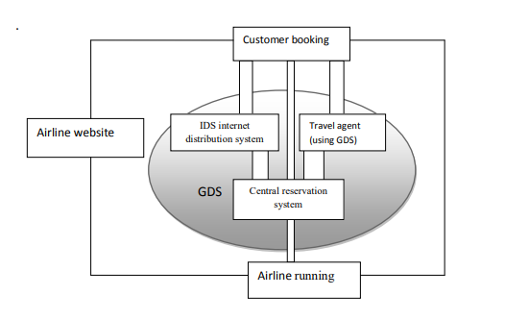

*Figure 2.1 showing a global distribution system; adapted from Reservation Interfaces.* [21]

**2.4 Components of Reservation Information Systems.**

These are complete Information Technology subsystems that make the reservation Information System operational; they are compatible in nature and the failure of one component may affect the operation of the others with in the system. They consist of computer resources, data, people, and procedures used in the modern business enterprise [15].

**2.4.1 Hardware**

O’Brien defines hardware as individual physical devices and material used in information processing. Specifically, it includes not only machines like computers but also data media i.e. all tangible objects on which data are recorded from sheets of paper to magnetic disks. Others include keyboards, mouse, printers, scanners etc. [15]

**2.4.2 Software**

Rochester assert that software includes all sets of information processing instructions and it comprises of different types of programs that enable the hardware to carryout different tasks. Software is further categorized into system software and Applications software. System software is concerned with keeping the computer system working while Application software is the general purpose or written for a specific task like stock control. It may be written using a programming language or more general purpose piece of software such as database. [6]

**2.4.3 Data**

Rochester defines data as all raw and unprocessed facts that can readily be used. Cleary no database system can exist without data. The basic factor upon an organization’s processing and information needs are founded. Data elements and relationships must be precisely defined and the definitions must be accurately recorded in the data dictionary. [6]

**2.4.4 People**

According to O’Brien, these are required for the operation of all information systems. They include end-users and information system specialists. End-users are people who use an Information System. The reservation information system specialists help in the development and operation of information system. They include system analysts, programmers, computer operators and others. People, are probably the component that most influence the success or failure of information systems [15].

**2.4.5 Procedures**

These are set of instruction about how to combine the above components in order to process the information and generate the desired output. They consist of the way how to log on to the DBMS, use of different forms and manipulations throughout the project. [25]

**2.4.6 Database**

Merril Wells defines Database as a collection of non-redundant data, which can be shared by different application systems. Or database is a collection of data as well as programs required to manage that data. According to Merril Wells the importance of data has been obvious from time immemorial. Before the advent of computers, this was written in books or registers; these could be considered as „manual‟ databases. Ever since computers were introduced as a means of sorting data, the concept and structure of a database have undergone a sea change. Database creation and maintenance is a gradual and continuous procedure being influenced by system software such as database management systems [18].

Database users state their requirements to the database using the data definition languages (DDL) and the data manipulation languages (DML) via the database management systems. The database management system surely provides an interface between the users programs and contents of the data base. During the creation and subsequent maintenance of the data base contents, the DDL and the DML are used for the following, add new files, expand the database, delete the absolute records, adjust data, and expand the database capacity, link up the data items and many others. [18]

**2.5 Types of Reservations in Reservation System**

1. **Guaranteed Reservation:**

Payments must be made in guaranteed reservations even if the client fails to come, except where the airline's cancellation processes are implemented. This guarantees that the business will keep an item for the client until a given time after the planned deadline of the service. In exchange, the client must ensure his/her reservation of an item unless reservation is properly canceled [22]. In order to guarantee a reservation, customers might opt for one of the following methods;

• Prepayment guaranteed reservation

• Credit card guaranteed reservation.

• Advance deposit or partial payment

• Travel agent guaranteed reservation

1. **Non-guaranteed Reservation:**

Insures that the company agrees to hold an item for the customer until a stated reservation cancellation hour on that day. A reservation agent always makes sure to encourage their customers to guarantee their reservations especially in the high season [22].

**2.6 Types of Information System**

Information System is a combination of people, hardware, software, communication devices, network and data resources that processes (can be storing, retrieving, transforming information) data and information for a specific purpose [23]. The types are;

**2.6.1 Transaction Processing System (TPS)**

This is a computerized system that performs and records daily routine transactions necessary to the conduct of the business. TPSs are information systems that process data resulting from the occurrence of business transactions. Example: payroll system; production instructions [16]

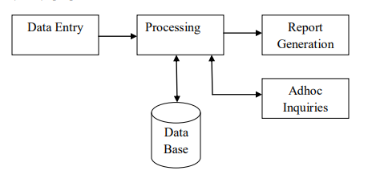

*Figure 2.2 Five Stages of Transaction Processing System[24]*

**2.6.2 Management Information System (MIS)**

These are mainly concerned with internal sources of information. MIS usually take data from the transaction processing systems and summaries it into a series of management reports. Hence MIS provides information for managing an organization. Information from MIS helps managers to monitor and direct the organization. Data Entry Processing Report Generation Adhoc Inquiries Data Base [23].

**2.6.3 Decision-support systems (DSS)**

These are specifically designed to help management make decisions in situations where there is uncertainty about the possible outcomes of those decisions. DSS comprise tools and techniques to help gather relevant information and analyze the options and alternatives. DSS often involves use of complex spreadsheet and databases to create "what-if" models [18].

**2.6.4 Executive Support System (ESS)**

This is designed to help senior management make strategic decisions. It gathers analyses and summarizes the key internal and external information used in the business. A good way to think about an ESS is to imagine the senior management team in an aircraft cockpit with the instrument panel showing them the status of all the key business activities. ESS typically involves lots of data analysis and modeling tools such as "what-if" analysis to help strategic decision-making [13].

**2.7 Advantages of Reservation Information Systems**

Convenience: One advantage of booking a hotel, flight or car rental online is the convenience. Being able to make all your travel plans on the Internet means you can do it any time of the day or night at home, or while you are on your lunch break at the office. Customers on the go can even make reservations on their smartphones or tablets. There is no need for lengthy phone calls or visits to a travel agency, with just a few minutes and a click of the mouse, you will have all your plans finalized, [10]

Changes and Cancelations: it is simple for travelers to change or cancel online reservations. Instead of calling the hotel or airline and waiting for a customer service representative to help you through the process, booking online means you can do it wherever you have Internet access.

Customer Reviews: Making a reservation over the phone or at a travel agency does not allow you to check out what past customers have thought of hotel chains or certain airlines. Another benefit of making online reservations is being able to see these customer reviews [10].

**2.8 Chapter Summary**

This chapter offers a comprehensive overview of the history, components, types, and advantages of reservation information systems in the airline industry. It underscores the pivotal role technology plays in enhancing airline operations and customer experiences

**CHAPTER THREE**

**SYSTEM ANALYSIS AND DESIGN**

**3.0 Introduction**

This chapter focuses on System Analysis and Design for the development of airline reservation system. It encompasses the selection of a suitable software development model, requirement engineering processes, and system design principles that will guide the development of the airline reservation system

**3.1 Software Development Model**

The software development model chosen for the project Airline Reservation System is Waterfall Model. The waterfall model is a sequential software development process. It consists of distinct phases like requirements gathering, design, implementation, testing, and maintenance. Each phase is completed before moving to the next. It's used when requirements are well-defined and unlikely to change [26].

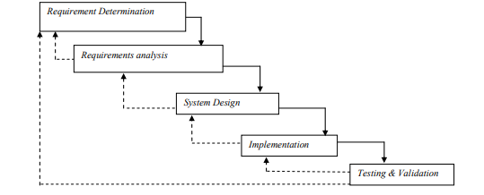

*Figure 3.1 Showing a Waterfall Development Life Cycle* [28]

**3.1.1 Justification for using the Waterfall Model**

The justification for using the waterfall model is that it provides a structured and sequential approach to software development. It allows for better planning, clear documentation, and easier tracking of progress. It works well when requirements are well-defined and unlikely to change throughout the development process. However, it may not be suitable if there's a need for flexibility and frequent changes in requirements.

**3.2 Requirement Engineering**

Requirement engineering is the process of defining, analyzing, and documenting the requirements for a system. It involves working with stakeholders to understand their needs and turning those needs into a specification that can be used to develop the system [27].

**3.2.1 Feasibility Report:**

The feasibility report of an airline reservation system would look at the technical, and operational feasibility of the system. The technical feasibility would look at whether the system is technically possible to implement and the operational feasibility would look at whether the system is workable in terms of the organization’s existing resources and processes

|  |  |
| --- | --- |
| Technical feasibility | Operational feasibility |
| The hardware and software requirements for the system are readily available because they're based on standard, off-the-shelf components. For example, the system can be built using a standard web server, database server, and programming language. This means that there is no need for custom hardware or software to be developed, which reduces the cost and time required to build the system. | The system should be easy to use because it should have a user-friendly interface that is intuitive and easy to navigate. It should also be easy to learn, so that employees and customers can start using it quickly and without a lot of training. Therefore the system is operationally feasible. |
| The database purpose was to create, establish ad among entities to facilitate all concerned users is their various capacilities or roles. Permission to the users would be granted based on the roles specified. Therefore, it provides the technical guarantee of accuracy, reliability and security. |  |

**3.2.2 Requirement Elicitation & Analysis**

This process are crucial parts of requirement engineering. These steps involve gathering information about the user’s needs and requirements, and then analyzing that information to ensure the requirements are clear, complete, and feasible. There are some common data collection methods which include surveys, interviews, questionnaire, brainstorming, prototyping, observations, focus groups, experiments, and secondary data analysis. [29] But in this project we use brainstorming and prototyping.

**3.2.3 Requirement Specification**

A requirement specification for an airline reservation system would define the specific functional and non-functional requirements of the system. Functional requirements would include things like the ability to search for flights, book flights, and manage reservations. Non-functional requirements would include things like performance, security, and usability.

**Functional Requirement**

|  |  |  |
| --- | --- | --- |
| REQUIREMENT | DESCRIPION | STORIES |
| R1. Create an account | Allows new users to register and create accounts with unique usernames and passwords. | R1. REGISTER ACCOUNT  INPUT: User provides registration details.  OUTPUT: Your account has been created.  PROCESSING: Create a new user account. |
| R2. Login | Allows users to securely access their accounts by providing valid credentials. | R2. LOGIN  INPUT: User provides username and password  OUTPUT: You have successful Login.  PROCESSING: Validate user credentials and grant access. |
| R3. Search a flight | Enables users to search for flight based on criteria like from origin, to destination and departure date. | R3. SEARCH A FLIGHT  INPUT: User provides search criteria.  OUTPUT: Display search results to the user  PROCESSING: Perform a search based on user criteria. |
| R4. Book a flight | Enable users to book a flight by entering passenger information and payment details. | R4. BOOK A FLIGHT  INPUT: User click a book button.  OUTPUT: The flight is Booked.  PROCESSING: validate payment information and confirm successful bookings. |
| R5. View reservation | Let’s users see the details of their reservation. | R3.1 VIEW RESERVATION  INPUT: User selected option out of options.  OUTPUT: Flight reservation details are displayed to the user.  PROCESSING: Retrieve and display reservation details. |
| R6. Cancel/ reschedule a reservation | Allows user to cancel/ reschedule the reservation based on criteria like ticket number and flight number | R6. CANCEL/ RESCHEDULE A FLIGHT  IPUT: Users provide information on the ticket number and the flight number to cancel the booking.  OUTPUT:  PROCESSING: |
| R7. Admin Login | Allows administrators to securely access the admin panel by providing valid credentials. | R7. ADMIN LOGIN  INPUT: Admin provides username and password.  OUTPUT: Admin gains access to the admin panel.  PROCESSING: Validate admin credentials and grant access. |
| R8. Admin Add flight | Admin can add flight schedule like flight id, Airplane id, date, starting time. | R8. ADMIN ADD FLIGHT  INPUT: Admin provides flight details.  OUTPUT: flight details is added to the system.  PROCESSING: Upload a new flight to the system. |
| R9. Admin Edit flight | Admin can make changes to flight schedules. | R9. ADMIN EDIT FLIGHT  INPUT: Admin provides updated flight details.  OUTPUT: Flight details are updated.  PROCESSING: Retrieve and modify the flight schedule data. |
| R10: Admin Delete Bookings | Admin can delete existing booking from the system. | R7.1 ADMIN DELETE  INPUT: Admin selects a booking to delete.  OUTPUT: Booking is removed from the system  PROCESSING: Retrieve and delete the booking data. |
| R11. Logout | Allows users to log out of their accounts for privacy and security. | R11. LOGOUT INPUT: User click the logout button  OUTPUT: You have successful Logout.  PROCESSING: Terminate the user's session. |

**Non-Functional Requirement**

* **Scalability:**
* The system shall be capable of handling a specified number of users and transactions per second to ensure smooth operation during peak times.
* **Security:**
* The system shall adhere to industry security standards and protocols to protect sensitive user data.
* User authentication and authorization mechanisms shall be tough.
* **Usability:**
* The system shall be designed to be user-friendly and intuitive.
* User interfaces shall be clear, with easy navigation.
* User documentation and help features shall be available to assist users.

**3.2.4 Requirement Verification & Validation**

Verification ensures that the specified requirements align with the project's goals, while validation ensures that the final product meets these requirements. This process helps maintain the quality and consistency of the airline reservation system

**3.3 System Design**

This showed the application of system theory to product development by defining the architecture, components, modules, interfaces and data for a system to satisfy specified requirements. The goal of design phase was not just to produce a design for the system; instead it was to find the best possible design within the limitations imposed by the requirements and the physical as well as the social development in which the system was to operate [26].

**3.3.1 Use case**

A Use case diagram is a way to summarize details of a system and the users within that system. It is generally shown as a graphic depiction of interaction among different elements.

Customer Admin

**Figure 3.3.1: Use case Diagram**

**3.3.2 Activity Diagram**

Activity diagrams are graphical representations of workflows of stepwise activities and actions with support for choice, iteration ad concurrency

**Figure 3.3.2: Activity Diagram**

Enter personal info

Search Availability

Enter arrival/ Departure Dates

Select flight

Hold reservation

Payment information

Process Payment

Marks seats taken

Email confirmation

Yes

No

**Figure 3.3.2.1 Showing Activity Diagram for a Customer**

Login in to system

Check use level and permission

Logout from the system

Manage reservation

Manage airlines

Manage passenger

Manage Ticket

Manage Booking

**Figure 3.3.2.2 Showing Activity Diagram for Admi**n

**3.3.3. Entity Relationship Diagram**

Entity Relationship (ER) Diagram describe things of interest in a specific domain of knowledge. A basic ER model is composed of entity types and specifies relationships that can help exist between entities.

**3.3.3 Figure of Entity Relationship**

CREDIT CARD_DETAILS

Profile_id (FK)

card_number

card_type

Expiration_month

Expiration_year

Password

First_name

Last_name

Address

Tel_no

Email_id

Profile_id

flight_id

airplane_id

airplane_name

From_location

to_location

departure_time

arrival_time

duration

total seats

ticket_id

profile_id

flight_id (FK)

flight_departure_date

status

flight_id (FK)

flight_departure_date

Price

available_seats

FLIGHT

TICKET INFO

PASSENGER_PROFILE

FLIGHT_DETAILS

**Figure 3.3.3 Entity relationship Diagram**

**3.4 Summary**

This Chapter focuses on software analysis and design. It starts with an introduction that outlines what the chapter entails. The software development model used is described, along with its working principles and justification for choosing it. Requirement engineering is then discussed, including the processes of feasibility report, requirement elicitation & analysis, requirement specification, and requirement verification & validation. Each process is documented for project. Finally, the chapter covers system design, which involves outlining the software design using Use Case, Activity Diagram, and Entity Relationship.

CHAPTER FOUR

SYSTEM IMPLEMENTATION

**4.0 Introduction**

This chapter highlights the essential components of system implementation, including the tools and technologies used, system testing, hardware and software requirements, and system evaluation. It's a crucial stage where the theoretical framework is put into practice, leading to the development of the actual system.

**4.1 System Implementation tools used**

In this project Airline reservation system, the Tools Used as the primary tools is PHP scripting language to implement most of functions, while MySQL is used as a database. PHP is a server scripting language, and a powerful tool for making dynamic and interactive Web pages. PHP is an excellent choice for web-based applications due to its vast developer community, extensive documentation, and compatibility with various web servers. It can seamlessly integrate with HTML, making it well-suited for web development projects. MySQL is an open-source relational database management system (RDBMS) known for its speed, reliability, and scalability. It is widely used for managing structured data. PHP plays a central role in the implementation of this project. It allows us to create the back-end logic of the system. This includes handling user authentication, processing reservations, managing databases, and generating dynamic web content. MySQL serves as the database management system for the airline reservation system. It stores and manages all the data related to flights, reservations, user accounts, and more.

PHP serves as the server-side scripting language responsible for implementing the system's logic and user interface, while MySQL manages the structured data required for storing information. This combination of PHP and MySQL is well-suited for developing a dynamic and reliable web-based system.

**4.2 System Testing**

The following table presents test cases for various functions in the software:

|  |  |  |  |  |  |
| --- | --- | --- | --- | --- | --- |
| TEST ID | FUNCTION | DESCRIPTION | EXPECTED RESULT | ACTUAL RESULT | STATUS |
| 1 | Register | New user registration | Registration Successful | Registration Successful | Successful |
| 2 | Login | Authorized users login in to the system | Authorized users gain access | Authorized users gain access | Successful |
| 3 | Add flight | Admin try to add flight schedule | Flight added to the system | New flight were added | Successful |
| 4 | Edit flight | Admin try to Edit the flight | Editing flight successful | Editing flight successful | Successful |
| 5 | Search a flight | Searching for a fight | Search flight displayed | Search flight displayed | Successful |
| 6 | Book a flight | User try to book flight | User book a flight | Flight was booked | Successful |
| 7 | View booking history | Try to View a booking history | Available booked flight displayed | Available booked flight displayed | Successful |
| 8 | Delete a flight | Delete a flight schedule from the system | Deleting flight successful | Deleting flight successful | Successful |
| 9 | Cancel a flight | Try Canceling a flight | Cancel flight  successful | Cancel flight successful | Successful |
| 10 | Logout | Try to logout from the system | Logout Successful | Logout Successful | Successful |

**4.3 System Requirement**

To use the software, both hardware and software requirements are necessary.

**Hardware Requirements:**

A computer system with a minimum of 10GB hard disk memory.

At least 250MB of RAM (512MB or more recommended).

A Pentium III processor and above.

Input devices, such as a mouse and keyboard.

Output devices, including an SVGA monitor.

**Software Requirements:**

The software can be installed on systems with the following software:

**I.** **System Software:** Any Windows operating system starting from Windows 2003, Windows XP Professional, Windows 7, 8, or 10. Windows XP Professional and Windows 8 are recommended for improved speed and efficiency.

**II.** **Application Software:** The application interface and database are designed and coded using Visual Studio code, Google chrome.

* 1. **Chapter Summary**

Chapter Four serves as a crucial stage in the project, moving from the conceptualization of the airline reservation system to its practical implementation. It highlights the core tools, testing procedures, system requirements, and evaluation criteria that guide the development and ensure the system's readiness for real-world usage.

CHAPTER FIVE

SUMMARY, CONCLUSION AND RECOMMENDATION

**5.0 Introduction**

Chapter Five serves as the conclusion of the Airline Reservation System project, offering a comprehensive overview of the work done, its implications, and potential areas for future enhancements. This chapter encompasses three key sections: Summary, Conclusion, and Recommendation.

**5.1 Summary**

In summary

Chapter One: Introduction to Airline Reservation Systems, Provides an introduction to the airline industry's desire for improvement and the evolution of airline reservation systems. It emphasizes the importance of reservation systems for organizing bookings, schedules, and customer data. Discusses the significant impact of technology on the airline industry. Identifies challenges with the manual ticketing process and sets the aim and objectives for the study. Defines the scope of the study, which is focused on designing and implementing a reservation system for local flights. Highlights the significance of the study for airlines and customers.

Chapter Two provides a comprehensive overview of reservation information systems in the airline industry. It delves into the history, components, types, and advantages of these systems.

The chapter emphasizes the pivotal role that technology plays in enhancing airline operations and elevating the overall customer experience.

Chapter Three: Software Analysis and Design. It describes the chosen software development model and justifies its selection. The chapter covers requirement engineering processes, including feasibility reports, requirement elicitation & analysis, requirement specification, and requirement verification & validation. It addresses system design and outlines the software design using tools such as Use Case, Activity Diagram, and Entity Relationship.

Chapter Four: It highlights the core tools, testing procedures, system requirements, and evaluation criteria that guide the development and ensure the system's readiness for real-world usage.

Chapter Five: conclusion

**5.2 Conclusion**

In conclusion, The Airline Reservation System has led to ease of airline ticketing, flight scheduling and also provided a means for customers to access and book flights from their homes. It has also increased the speed with which information about customers are retrieved and handled and flight scheduling is tasked. Owing to the ease and comfort of Airline Reservation system and the advancement in mobile Technology local flights which are not on the system should be encouraged to compensate the system.

Throughout this project, we considered the needs of our users and aimed for a user-friendly system. We also conducted rigorous testing to ensure the system's functionality and reliability.

**5.3 Recommendation**

Although after putting lot of efforts to complete this project, identified some negative areas where it needs more attention to cover those areas. The following recommendations will be done in the next phase of the system.

1. Implement additional security layers, such as two-factor authentication (2FA), to further protect user accounts and sensitive data.
2. Implement features like seat selection, special meal requests, or preferences to enhance the booking experience.
3. Ensure that the system is fully optimized for mobile devices, as many users prefer to make reservations using smartphones and tablets. Consider developing a dedicated mobile app or a responsive web design.
4. Establish robust data backup and recovery mechanisms to prevent data loss in the event of a system failure or data corruption.
5. Schedule regular audits of the system's security, performance, and functionality to maintain the highest standards.
6. Provide a robust customer support system, including a helpdesk, for users who encounter problems or need assistance during their reservation process.
7. Consider expanding the system to cover international flights, as this can open new revenue streams and attract a broader customer base.

**Reference**

[1] Winston, Clifford, 1995 "The Evolution of the Airline Industry", Brookings Institution Press, ISBN 081575843X. Cf. p.61-62, Computer Reservation Systems

[2] Pooja, G. (2015). Online Airline Ticketing System Centria University of Applied Sciences, Kokkola, Finland.

[3] Oyelade, O. J., Fatumo, S. A., Azeta, A. A., & Ayo, C. K. (2009). Development of a mobile airline reservation system. Journal of Computer Science & Its Application, 16(1), 58-59.

[4] Cambridge. (2019). Reservation | meaning in the Cambridge English dictionary. In Cambridge Dictionary | English Dictionary, Translations & Thesaurus. Retrieved February 4, 2019.

[5] American Airlines "Magnetronic Reservisor". American Airlines C.R. Smith Museum. Retrieved 3 August 2014.

[6] Rochester, Jack B. (1996). "Tools for Knowledge Workers” Using Computers in Information. Indianapolis, IN: Que Education and Training.

[7] Rouse, M. 2015 E-commerce (electronic commerce or EC) definition, Available: http://searchcio.techtarget.com/definition/e-commerce/. Accessed 10th February, 2019

[8] Ueland, S. (2013) 11 alternative payment options. Retrieved February 4, 2019, from <https://www.practicalecommerce.com/11-Alternative-PaymentOptions>

[9] Winston, Clifford, 1995 "The Evolution of the Airline Industry", Brookings Institution Press, ISBN 081575843X. Cf. p.61-62, Computer Reservation Systems

[10] Diane (1993) Computer Reservation Systems: “Action Needed to Better Monitor the CRS Industry and Eliminate CRS Biases”, DIANE Publishing Company, ISBN1568069774

[11] Wikipedia (2012), http://en.wikipedia.org/wiki/Computer_reservations_system accessed on May 26, 2012.

[12] Wardell, David J, "Airline Reservation Systems", 1991. Research paper.

[13] Stair, Ralph M. (1996). Principles of Information Systems and Managerial Approach, 2nd ed. Cincinnati, OH: Boyd & Fraser. . [Accessed May, 19, 2012].

[14] R. Doganis, C. Routledge (2002): “Flying Off Course: The Economics of International Airlines,” 3rd Edition. McGraw-Hill, New York

[15] James a. O‟Brien (2001). Management information system

[16] Kantar, (1997). Managing with information. 4th edition

[17] M. J. Smith (2002): “The Airline Encyclopedia, 1909 – 2000”. Scarecrow Press, New York.

[18] Merril Wells (2002) “Introductory Microsoft Access 2002”

[19] Finley, P. N. (1994). Introducing decision support systems. Oxford, UK Cambridge, Mass., NCC Blackwell; Blackwell Publishers.

[20] Parker, D. (2016, August 16). Airline reservations systems: A brief history. Retrieved May 4, 2019, from <https://airlinegeeks.com/2016/08/16/airline-reservations-systems-a-brief-history/>

[21] Pranjali Kharwade, Vaibhavi Datey, Isha Gujakar, Vidhi Sharma,Shweta Hole, Vivek Gupter IJCSMC 3 (10), 393-397,2014

[22] ReservationInterface(2012),http://www.asppms.com/autoclerk/Products/Interfaces/Reser vationInterfaces/InterfacetoGDS.aspx(retrived on 23.May.2012)

[23] BusinessDictionary.com. Retrieved May 30, 2019, from BusinessDictionary.com website: <http://www.businessdictionary.com/definition/guaranteed-reservation.html>

[24] Prachi Juneja 2015 Management study guide.

[25] Expertsmind. (2003). Transaction processing system [Image]. Retrieved from [http://www.expertsmind.com/learning/transaction-processing-systems-assignment-hel p-7342872690.asp](http://www.expertsmind.com/learning/transaction-processing-systems-assignment-hel%20p-7342872690.asp)

[26] Stair, Ralph M. (1996) Principles of Information Systems and Managerial Approach, 2nd ed. Cincinnati, OH: Boyd & Fraser. [Accessed May, 19, 2012].

[27] Pressman, R.S. (2014). Software Engineering: A Practitioners Approach. McGraw-Hill Education.

[28] 2nd Edition. Andrew P. Sage 1992, Software Engineering

[29] “Research Methodology: A Step-by-Step Guide for Beginners” by Ranjit Kumar 1999

**Appendix A**

Welcome Page:

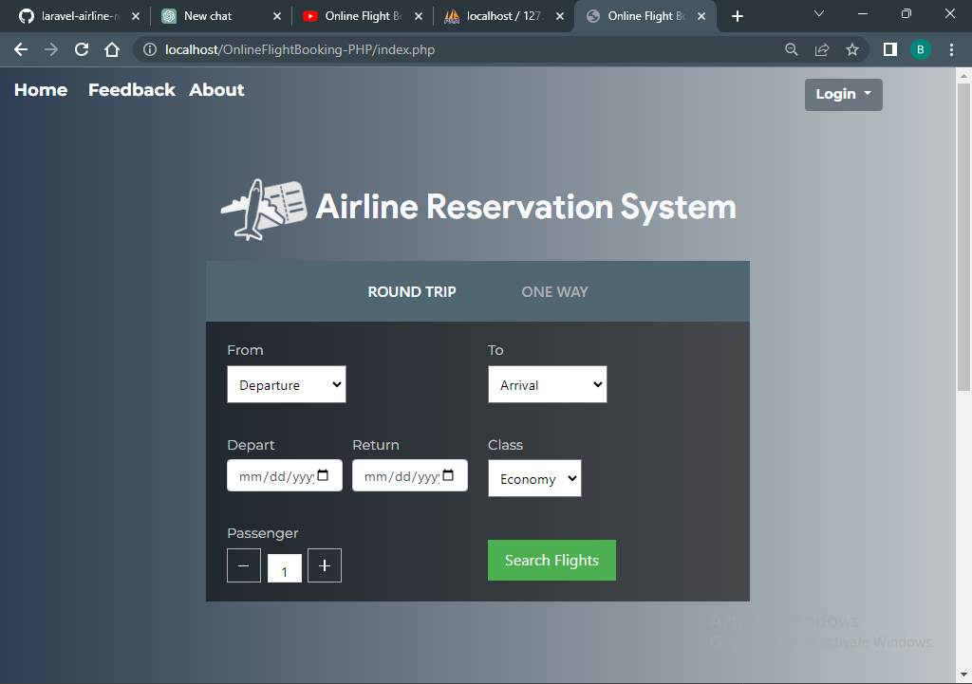

Login Page:

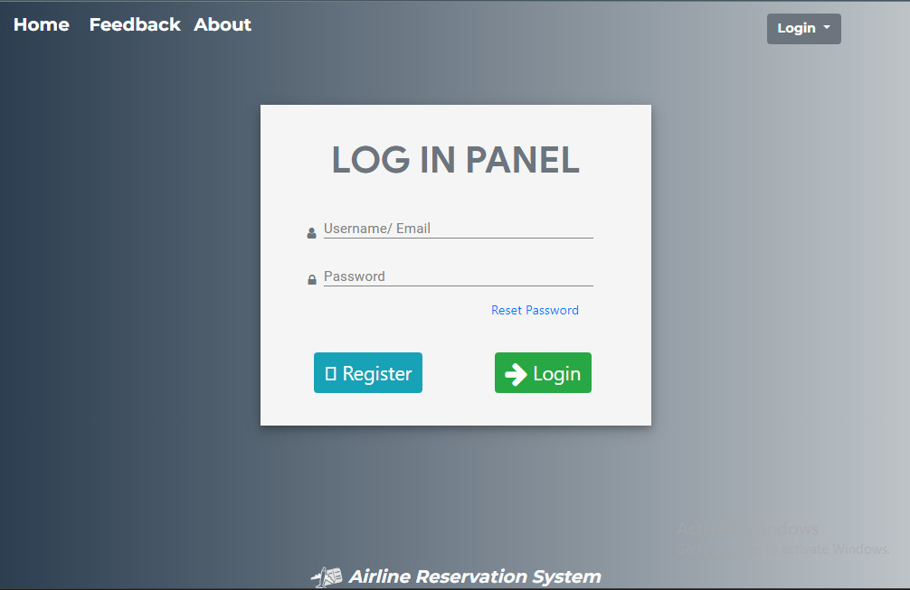

Register Page:

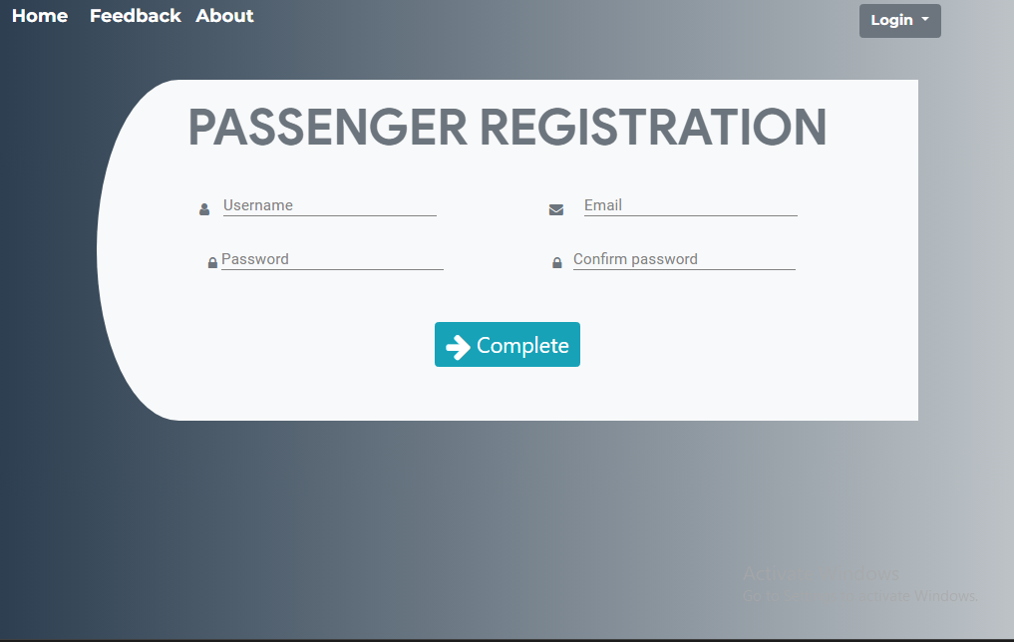

Flight search result

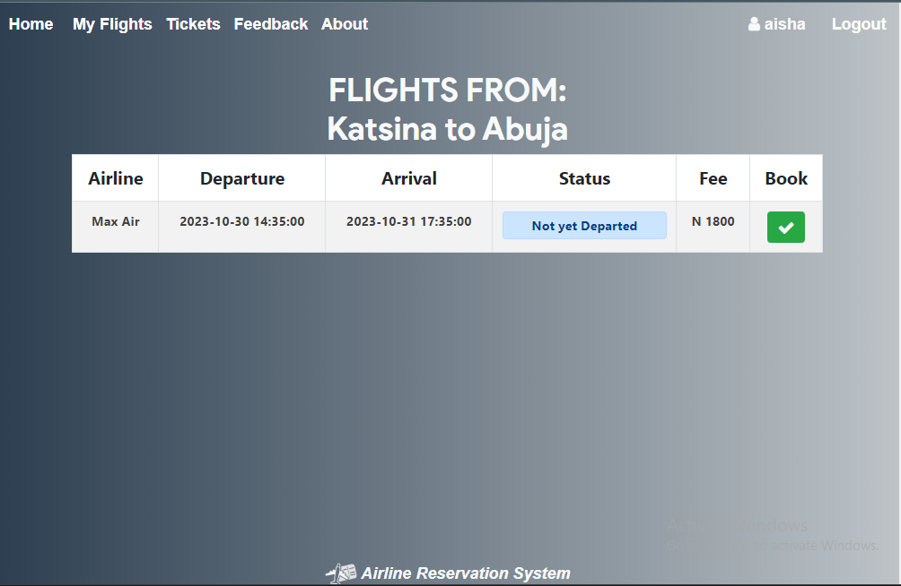

Flight History

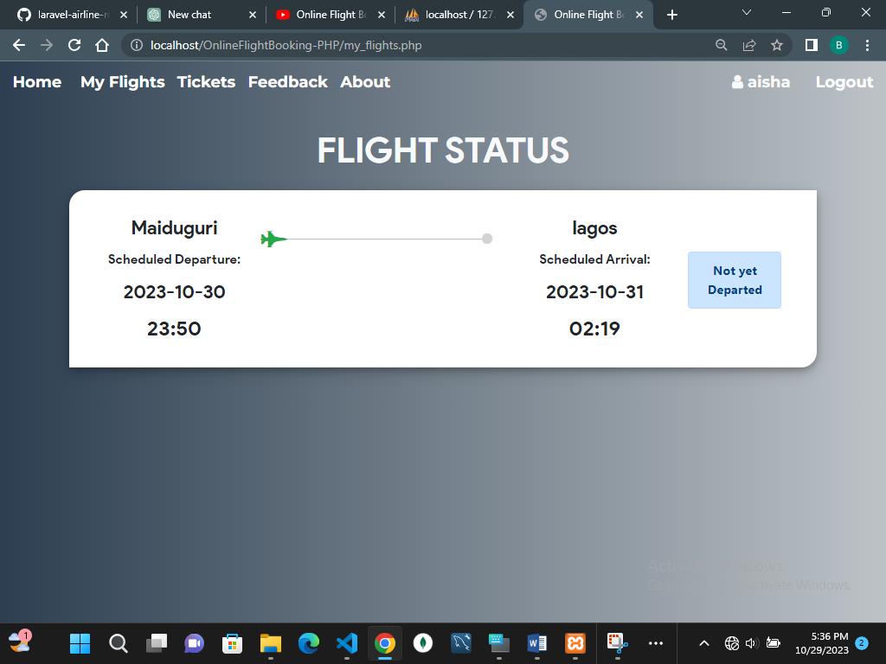

Booked ticket

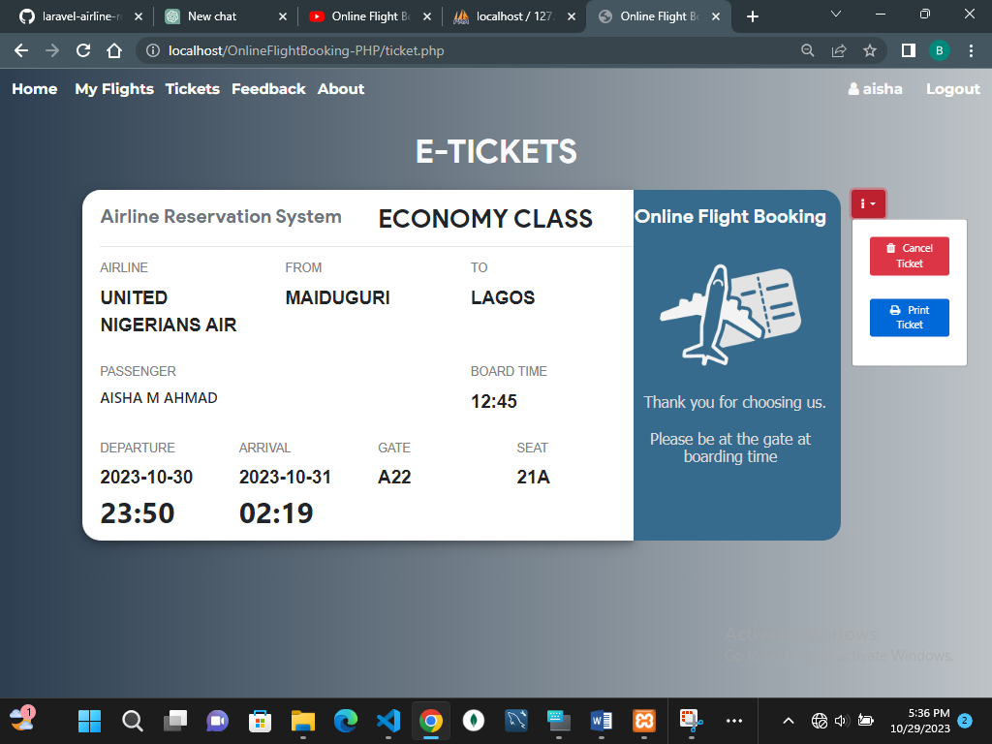

Admin Dashboard

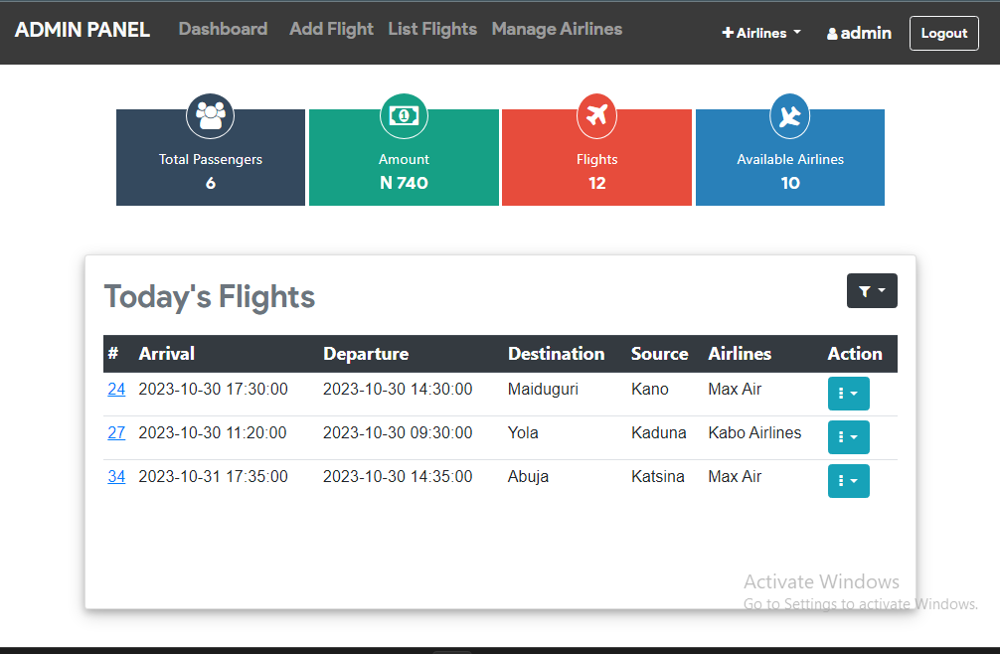

Add Flight schedule

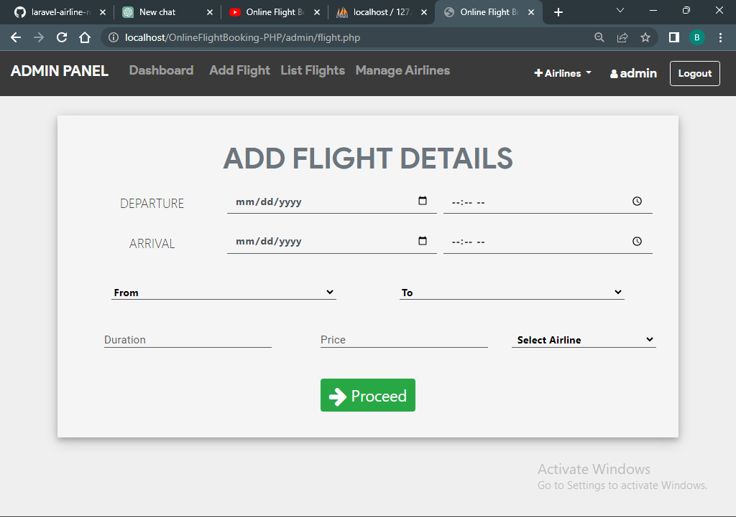

Flight List Interface

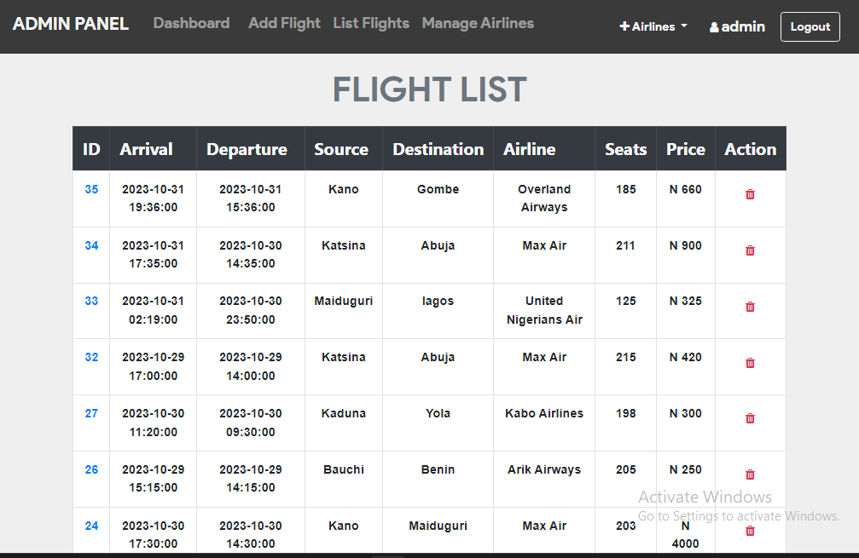

Manage Airlines Interface

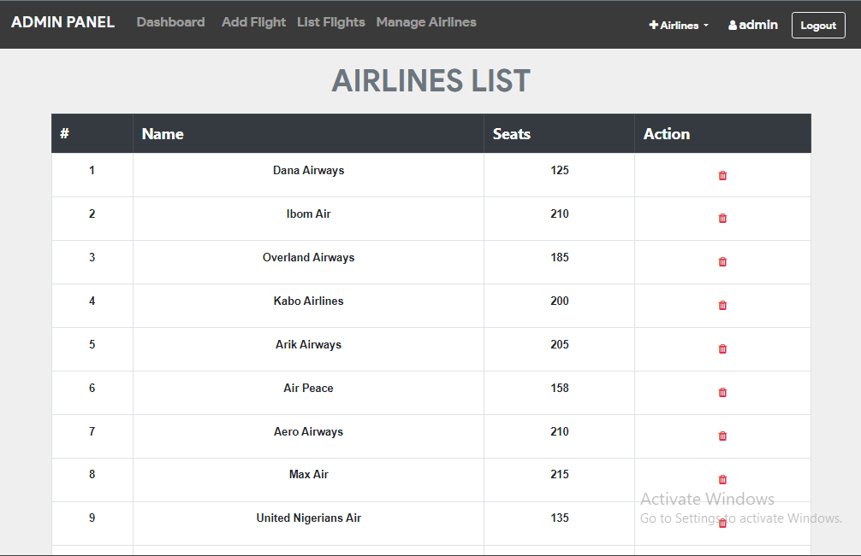

**Appendix B**

https://github.com/bielkeesu/Airline-reservation-system.git